**Chapter 8: Vectors and Scalars**

***Please remember to photocopy 4 pages onto one sheet by going A3→A4 and using back to back on the photocopier***

***It actually makes more sense to do this chapter after chapter 9, because most exam questions combine the two topics.***

**A *scalar quantity* is one which has *magnitude* only.** Examples: length, area, energy, time, volume, temperature.

**A *vector quantity* is one which has both *magnitude* and direction.** Examples: displacement, acceleration, force.

Vectors can be represented on a diagram by an arrow, where the vector is in the same direction as the quantity it is representing.

**Composition (addition) of two perpendicular vectors**



**Exam question** [2004]

Two forces are applied to a body, as shown.

1. What is the magnitude of the resultant force acting on the body?
2. What direction is the resultant force acting in?

**Solution**

* 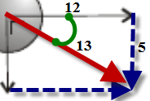When adding two vectors, they should be arranged tail-to-tail (the arrow represents the head) and the rectangle should then be completed.
* The resultant is the line joining the two tails to the opposite corner.
* The direction is from the tails to the opposite corner (angles usually given relative to the horizontal).
* Mathematically, the length of the vector can be found by using Pythagoras’ Theorem.
* The angle can be found by using Tan θ = $\frac{Opposite}{Adjacent}$  
  So θ = Tan-1 ()

1. Set up as shown  
   R2 = 52 +122

R = 13 N

1. The direction is from the tails to the opposite corner (angles usually given relative to the horizontal).

The angle can be found by using Tan θ = $\frac{Opposite}{Adjacent}$  
So θ = Tan-1 () θ = tan-1 θ = 22.620

“The vector has never been of the slightest use to any creature."

Lord Kelvin

**Resolving a vector into two perpendicular components**

We have just seen that two perpendicular vectors can be added together to form a resultant.

Now what about if we started off with the resultant. Would we be able to get back the two original vectors?

First we need to remember that for a right-angled triangle:

Cos θ = $\frac{Adjacent }{Hypothenuse }$, therefore Adjacent = Hypothenuse x Cos θ {Adj = H Cos θ}

Sin θ = $\frac{Opposite}{Hypothenuse }$, therefore Opposite = Hypothenuse x Sin θ {Opp = H Sin θ}

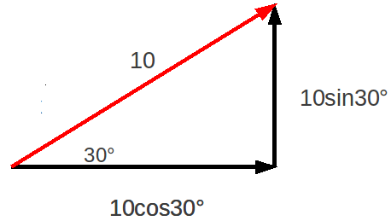**Examples**

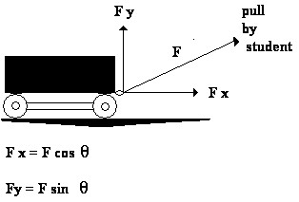

**Worked Example**

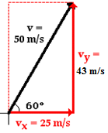Consider a velocity vector representing a velocity of 50 m s-1, travelling at an angle of 600 to the horizontal

Find the horizontal and vertical components

**Solution**

See diagram

The ***opposite*** is equal to ***H Sinθ,*** which in this case = 50 Cos 600 = 43 m s-1.

The ***adjacent*** is equal to ***H Cosθ,*** which in this case = 50 Sin 600 = 25 m s-1.

**Fill in the following table (leave your angle in surd form where possible)**

|  |  |  |  |
| --- | --- | --- | --- |
| **Magnitude** | **Angle** | **Horizontal component** | **Vertical component** |
| 20 | 450 |  |  |
| 10 | 300 |  |  |
| 8 | 750 |  |  |
| 20 | 600 |  |  |
| 12 | 150 |  |  |

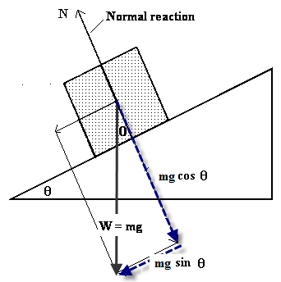

**We use this technique to calculate the component of the gravitational force that acts down a plane**

From the diagram we can see that the component of the gravitational force acting on the block *parallel to the surface of the plane (‘*pushing it down the plane’) is **mg s*inθ***

So F = ma now becomes

mg s*inθ* = ma

and we can use this to find out the acceleration of the block.

See the exam questions at the end.

**Exam Question: 2015 Question 5**

A hurler strikes a sliotar with an initial velocity of 41 m s⁻¹ at an angle of 30° to the horizontal.   
How far does the ball travel horizontally in three seconds?

vHorizontal = 41Cos300 = 35.51 m s–1   
s = (velocity)(time) = 35.51 × 3 = 106.52 m

**Experiment: To find the Resultant of Two Forces**

**Procedure**

1. 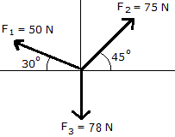Use cord to attach three weights to a central knot using either a force-table with pulleys as shown or alternatively using three newton-meters.

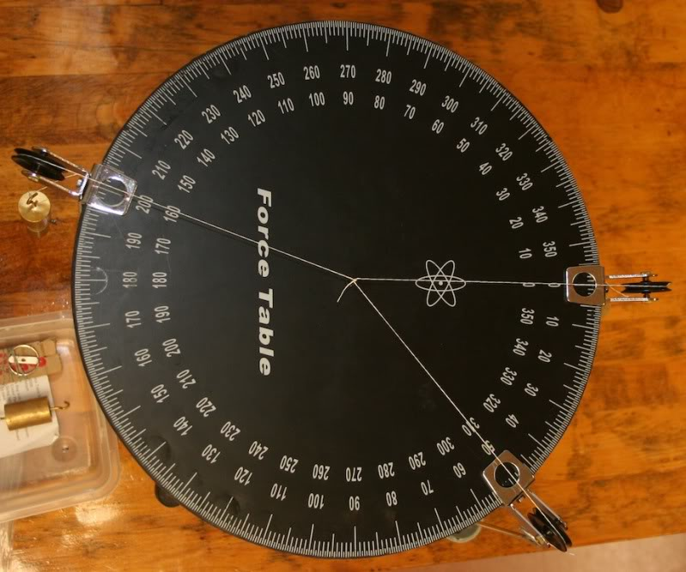

1. Adjust the size and/or direction of the three forces until the central knot remains at rest.
2. Read the forces and note the angles.
3. Resolve any two of the forces to find out their components along the axis of the third force (see example above).  
   Add both of these components.  
   From the example above, let’s assume the axis of the 50 N force is vertical and resolve all forces parallel to this axis:   
   The component of the 50 N force (top left) in the vertical direction = 50 Sin 300 = 25 Newtons (upwards)  
   The component of the 75 N force (top right) in the vertical direction = 75 Sin 450 = 53.03 Newtons (upwards)  
   The third force is acting downwards and is 78 Newtons  
   Result: total force upward approximately equal to force down.

**Conclusion**

The sum of the components of any two of the forces along the axis of the third force can now be shown to be equal in magnitude but opposite in direction to the third force.

**Leaving Cert Physics Syllabus: Vectors and Scalars**

|  |  |  |  |
| --- | --- | --- | --- |
| **Content** | **Depth of Treatment** | **Activities** | **STS** |
|  |  |  |  |
| Vectors and Scalars | Distinction between vector and scalar quantities. |  | Vector nature of physical quantities: everyday examples. |
|  |  |  |  |
|  | **Composition of perpendicular vectors.** | **Find resultant using newton balances or pulleys.** |  |
|  |  |  |  |
|  | **Resolution of co-planar vectors.** | **Appropriate calculations.** |  |

**Exam questions**

1. [2006 OL]Force is a vector quantity. Explain what this means.
2. [2003][2014]  
   Compare vector and scalar quantities.

Give one example of each.

1. [2003, 2014]  
   Describe an experiment to find the resultant of two vectors.
2. [2014]
3. A golfer pulls his trolley and bag along a level path.   
   He applies a force of 277 N at an angle of 24.53° to the horizontal.   
   The weight of the trolley and bag together is 115 N and the force of friction is 252 N.  
   Calculate the net force acting on the trolley and bag (in both the vertical and horizontal directions).
4. What does the net force tell you about the golfer’s motion?

***Parts (iii) and (iv) are a little tricky and best done in Sixth Year***

1. A force of 5.3 kN is applied to a golf ball by a club.

The mass of the ball is 45 g and the ball and club are in contact for 0.54 ms.

Calculate the speed of the ball as it leaves the club.

1. The ball leaves the club head at an angle of 15° to the horizontal.   
   Calculate the maximum height reached by the ball.   
   Ignore the effect of air resistance.
2. [2009]  
   A skateboarder with a total mass of 70 kg starts from rest at the top of a ramp and accelerates down it. The ramp is 25 m long and is at an angle of 200 to the horizontal.   
   The skateboarder has a velocity of 12.2 m s–1 at the bottom of the ramp.
3. Calculate the average acceleration of the skateboarder on the ramp.
4. Calculate the component of the skateboarder’s weight that is parallel to the ramp.
5. Calculate the force of friction acting on the skateboarder on the ramp.



1. [2003]
2. A cyclist travels from A to B along the arc of a circle of radius 25 m as shown.

Calculate the distance travelled by the cyclist.

1. Calculate the displacement undergone by the cyclist.
2. A person in a wheelchair is moving up a ramp at a constant speed. Their total weight is 900 N.   
   The ramp makes an angle of 10o with the horizontal.  
   Calculate the force required to keep the wheelchair moving at a constant speed up the ramp. (You may ignore the effects of friction.)

**Exam solutions**

1. It has both magnitude and direction
2. A vector has both magnitude and direction whereas a scalar has magnitude only.  
   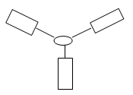e.g. velocity is a vector and speed is a scalar
3. Attach three newton-balances to a knot in a piece of thread.

Adjust the size and direction of the three forces until the knot in the thread remains at rest.

Read the forces and note the angles.

Resolve any two of the forces along the axis of the third force  
Conclusion  
The sum of the components of any two of the forces along the axis of the third force can now be shown to be equal in magnitude but opposite in direction to the third force.

1. Horizontal direction: Net force = Fforward -Fbackward

Forward force = horizontal component of force applied by golfer = 277 Cos 24.53° ≈ 252 N

Backward force = force of friction = 252 N

Net force ≈ 0 N

Vertical direction: Net force = Fup -Fdown

Force up = vertical component of force applied by golfer = 277 Sin 24.53° ≈ 115 N

Force down = weight = 115 N

Net force ≈ 0 N

The numbers here look questionable from an Applied Maths perspective:

If the vertical force applied by the golfer equals the weight of the trolley plus bag, then the reaction force R must be zero.

But if the reaction force is zero then there can’t be any friction.

1. The golfer is travelling at constant speed
2. **Calculate the speed of the ball as it leaves the club.**

There are a number of ways to do this. The following isn’t necessarily the shortest, but it might be the most familiar:

F = ma

5300 = .045 a

a = 117777.8 m s-1

Now use *vuast*: v = u +at

v = 0 + (117777.8) (0.54 × 10-3)

v = 63.6 m s–1

1. **Calculate the maximum height reached by the ball.**

uy = u sinϴ = 63.6 sin 150 = 16.46 m s–1

v2 = u2 +2as   
0 = (16.46)2 +2(-9.8)s

height = 13.82 m

OR you could have used: ½mv2 = mgh

1. **Calculate the average acceleration of the skateboarder on the ramp.**

Just use *vuast* v2= u2 + 2as ⇒ (12.2)2 = 0 +2a(25) ⇒ a = 2.98 m s–2

1. **Calculate the component of the skateboarder’s weight that is parallel to the ramp.**

W = mg sinθ = mg sin20 = 234.63 N

1. **Calculate the force of friction acting on the skateboarder on the ramp.**

Fnet = ma

Force down (due to gravity) – Resistive force (due to friction) = ma

Gravitational force – ma = friction force   
Gravitational force = 234.63 N (see part (ii) above) and ma = 70(2.98) = 208.38 N

234.63 – 208.38 = friction force = 26.25 N

1. **Calculate the distance travelled by the cyclist.**The *distance* is equivalent to one quarter of the circumference of a circle = 2πr/4 = 25π/2= 12.5π = 39.3 m**.**
2. **Calculate the displacement undergone by the cyclist.**Using Pythagoras: x2 = 252 + 252  x = 35.3 m. Direction is NW
3. **Calculate the force required to keep the wheelchair moving at a constant speed up the ramp.**   
   If the wheelchair is moving at constant speed then the force up must equal the force down.   
   So to calculate the size of the force up, we just need to calculate the force down:  
   Fdown = mg Sinϑ   
   = 900 Sin 10o  
   = 156.3